

Student Assessment Submission and Declaration

Student name: | Theodor-Marius Spita
 |  | BSU ID No | 583845
Submission date: |  |  | 27.03.2026
Programme: | Computer Science
Module name and code: | Databases CPU4005-20P
Title: | Database model with annotations
Assessor name:

Plagiarism

Plagiarism is a form of cheating. Plagiarism must be avoided at all costs and students who break the rules, however innocently, may be penalized. It is your responsibility to ensure that you understand correct referencing practices. As a university level student, you are expected to use appropriate references throughout and keep carefully detailed notes of all your sources of materials for material you have used in your work, including any material downloaded from the Internet. Please consult the relevant unit lecturer or your course tutor if you need any further advice.

Student declaration
I certify that the assignment submission is entirely my own work. I fully understand the consequences of plagiarism. I understand that making a false declaration is a form of malpractice.
Student signature: | Theodor-Marius Spita | Date: | 27.03.2026

ACADEMY MANAGEMENT DATABASE DESIGN

Table of Contents

Student Assessment Submission and Declaration 1
Conceptual diagram 4
Physical diagram 5
Short description 6
References 9

Conceptual diagram
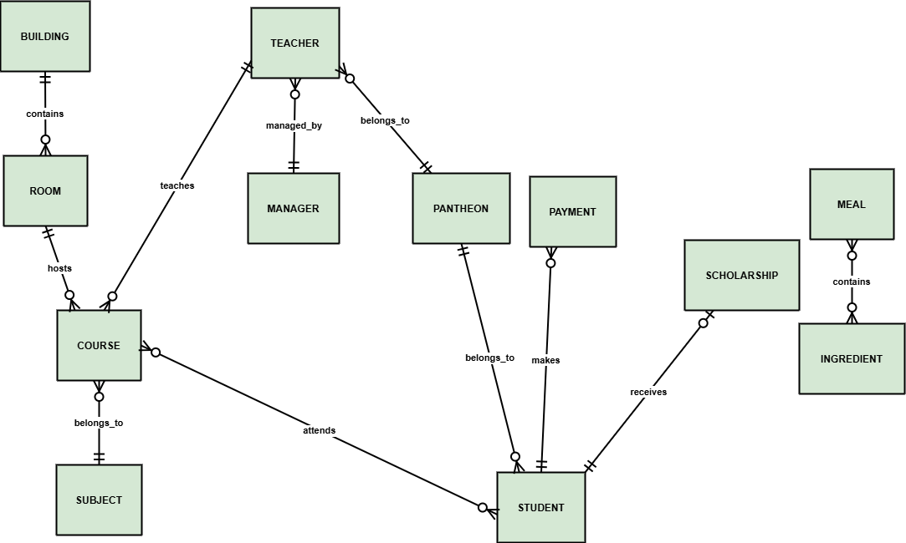
Figure 1: Conceptual ER Diagram
A conceptual ER diagram is a high-level view of the database system that would be built in the academy of villainous opportunity. It determines the key participants of the system, such as Student, Teacher, Manager, Course, Subject, Room, Building, Pantheon, Meal, Ingredient, Payment and Scholarship. The diagram is concentrated on the illustration of the relations between these entities without detailed attributes (Tarigan et al. 2024). The courses and students have a many-to-many relationship, whereas the teachers have a one-to-many relationship, suggesting that teachers can teach several courses. Courses are related to a subject, and the courses are in rooms and buildings, respectively. The organizational alignment is that both the students and teachers are attached to a pantheon. Also, payments are made by students, and they can also receive scholarships at will. Ingredients are related to meals in a many-to-many manner. In general, the conceptual diagram offers a simplified illustration of the system requirements derived during interviews, guaranteeing the clarity of relationships and cardinality.

Physical diagram
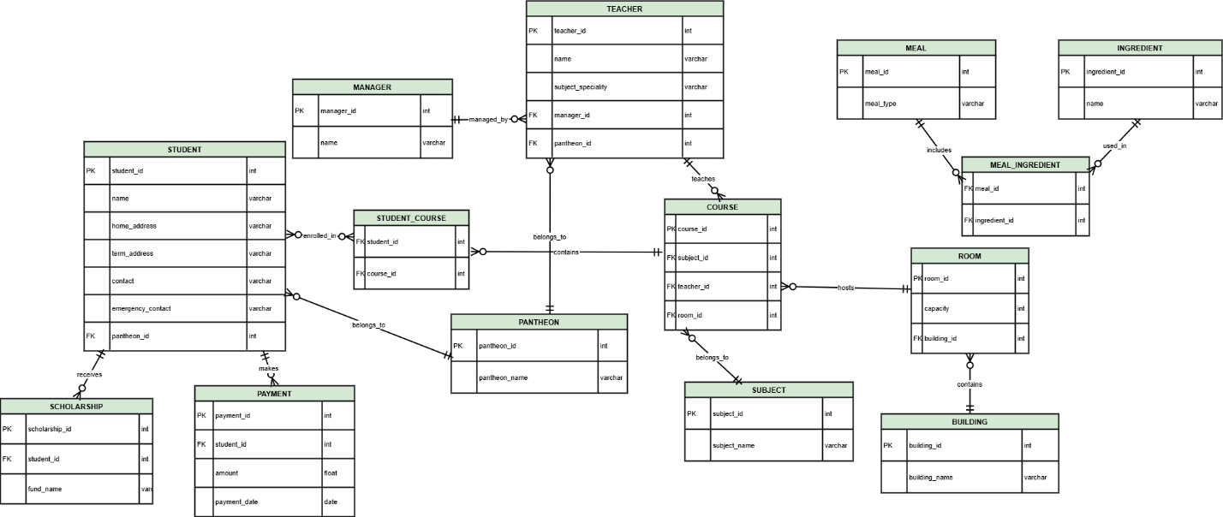
Figure 2: Physical ER Diagram
A physical ER diagram gives a specific representation of the database design through a translation of the conceptual model into the relational tables with attributes, primary keys, and foreign keys. The implementation of each entity is done in the form of a table, e.g. Student, Teacher, Course, Subject, Room and Building with distinct identifiers and data types. Primary keys are used to identify each record uniquely, whereas foreign keys are used to create relationships among tables. Associative tables, like Student Course and Meal Ingredient, are the solution to many-to-many relationships found in the conceptual model. Such tables make sure that they are normalized correctly and that they do not have redundancy. The fact that in the system, tables like Payment and Scholarship are included allows the system to control the financial transactions and sources of funds efficiently. Other constraints that are included in the diagram are the relationships between teachers and managers, as well as room reservations in courses. The design guarantees the integrity of data, scaling and efficient querying of the data; therefore, addressing the operational requirements of the institution.

Short description
The database design is created based on the main requirements of the interview data, which are extracted and converted into a structured model. This is initiated by identifying core entities like students, teachers, courses and facilities, after which the relationships between them are defined. The conceptual diagram is diagrammed in a manner that gives a high-level visualization of the relationships between various components that are involved in the system. This is enhanced by the physical diagram, which adds attributes, a primary key, and a foreign key, which are used to ensure that every table can be identified uniquely and related well (Fatmariani et al. 2023). The schema is designed in a Third Normal Form (3NF) because all the non-key attributes are dependent on the primary key only, and all transitive dependencies are eliminated. The details of the managers are included on a different table, instead of being contained in the teacher table, and this minimizes redundancy. Primary keys are selected as unique identifiers, such as student-id and teacher-id, to ensure consistency. The many-to-many relationships, like the one between students and courses, are addressed with the help of junction tables that offer efficient data management.

GitHub link for diagrams:

Entity | Primary Key | Key Attributes | Description
Student | student_id | name, home_address, term_address, contact, emergency_contact, pantheon_id | Stores all student personal and academic details
Teacher | teacher_id | name, subject_speciality, manager_id, pantheon_id | Contains teacher information and management hierarchy
Course | course_id | subject_id, teacher_id, room_id | Represents classes assigned to teachers and rooms
Subject | subject_id | subject_name | Defines subjects taught in the academy
Room | room_id | capacity, building_id | Stores room details and capacity constraints
Building | building_id | building_name | Represents physical infrastructure
Pantheon | pantheon_id | pantheon_name | Groups students and teachers by alignment
Table 1: Core Entities and Key Attributes

Relationship / Table | Type | Connected Entities | Description
Student_Course | Many-to-Many | Student ↔ Course | Tracks student enrolment in multiple courses
Meal_Ingredient | Many-to-Many | Meal ↔ Ingredient | Stores ingredients used in each meal
Payment | One-to-Many | Student → Payment | Records all student fee transactions
Scholarship | Optional (1:1) | Student → Scholarship | Stores scholarship or bursary information
Teacher_Manager | Many-to-One | Teacher → Manager | Defines reporting hierarchy
Room_Course | One-to-Many | Room → Course | Assigns rooms to courses
Table 2: Relationships and Associative Entities

References
Fatmariani, F., Putri, M.P. and Apriliani, M., 2023. Implementation of CV Metha Developing Palembang Goods Ordering System. Sinkron: jurnal dan penelitian teknik informatika, 7(1), pp.442-450.
Tarigan, F.J., Br Bukit, R. and Erwin, K., 2024. Analysis of Factors Affecting the Successful Implementation of Accounting Information Systems with Availability as a Moderating Variable in Online Queues with Entity Relationship Diagram Concepts in North Sumatra Provincial Type A Hospitals. International Journal of Research and Review, 11(6), pp.884-897.

